**2 урок**

ellipse(250,200,200,200);  
rect(250, 200, 150, 100);  
ellipse(350, 300, 100, 100);

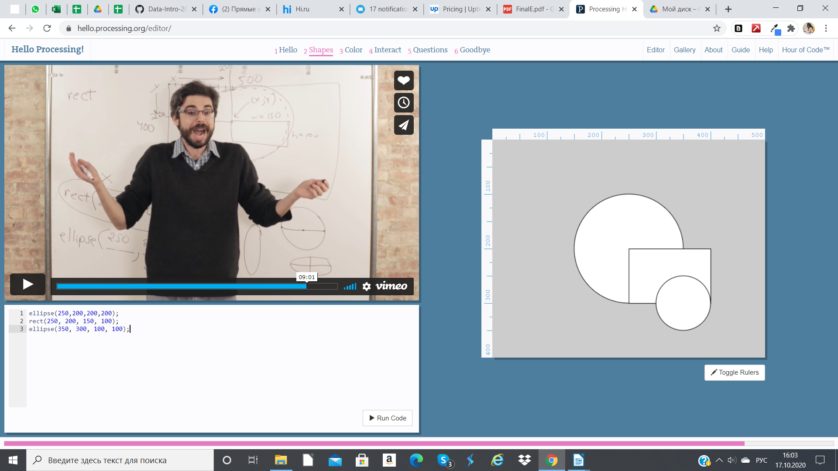

**Урок 3**

background(10, 80, 100);  
  
stroke(60, 100, 90);  
fill(50, 100, 70);  
ellipse(255, 100, 200, 255);  
  
fill(200, 110, 130);  
rect(255, 50, 20, 255);  
  
fill(200, 200, 200);  
ellipse(200, 190, 50, 0);

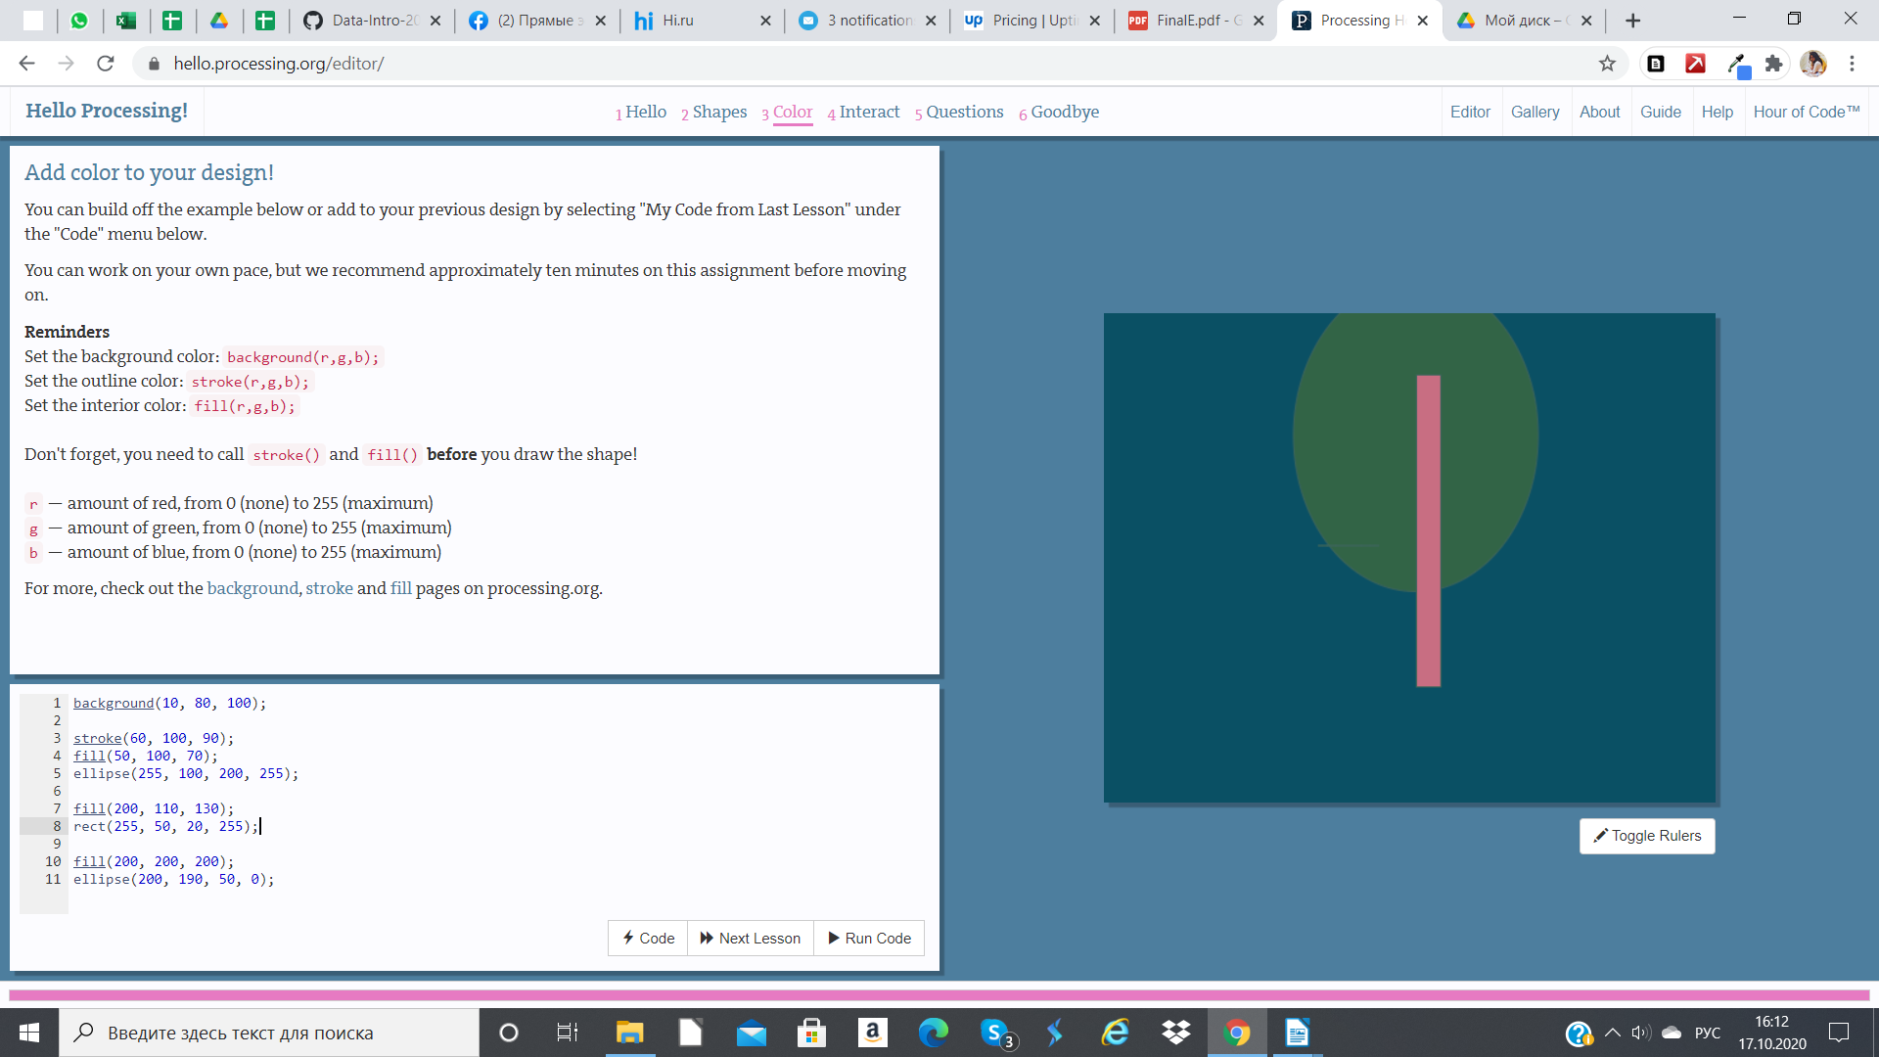

4 урок

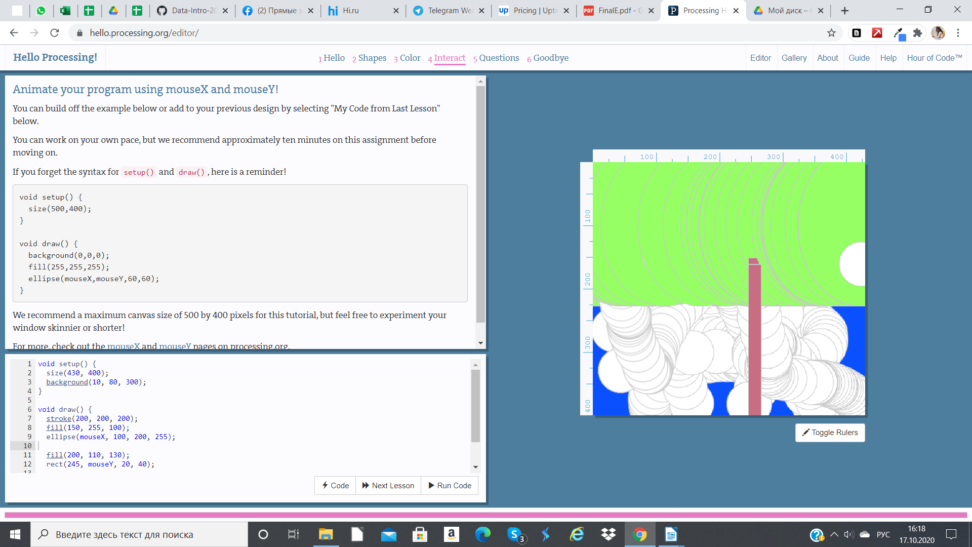void setup() {  
 size(430, 400);  
 background(10, 80, 300);  
}  
  
void draw() {  
 stroke(200, 200, 200);  
 fill(150, 255, 100);  
 ellipse(mouseX, 100, 200, 255);  
  
 fill(200, 110, 130);  
 rect(245, mouseY, 20, 255);

5 урок

void setup() {  
 size(390, 300);  
 background(20, 100, 120);  
}  
  
void draw() {  
 if (mousePressed) {  
 background(20, 100, 255);  
 }   
  
 stroke(200, 200, 200);  
 fill(150, 200, 100);  
 ellipse(mouseX, 100, 200, 255);  
  
 fill(150, 290, 200);  
 rect(230, mouseY, 20, 200);

